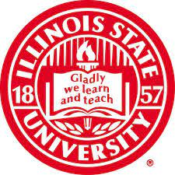
COLLEGE OF EDUCATION COUNCIL

November 28, 2022
12:00-1:30 pm

- CALL TO ORDER
- Adoption of the Agenda
3. approval of the minutes from September 2022 meeting
5. information Items
- Bylaws Update (Kristina Falbe)
- COEC Chair Course Release (Stacey Jones-Bock)

6. DISCUSSION ITEMS
- Working Together in More Accessible and Equitable Ways (Tech Subcommitee)
  - See attachment
- Shared Governance through COEC subcommittees (Kristina Falbe)
- Universities Framework on Continuous Improvement and Systems Thinking (Dean Francis Godwyll)

7. ACTION ITEMS

8. dean’s Report

Deans Report (Dean Francis Godwyll)

9. Adjournment

NEXT MEETING: January 23, 2022 @12:00 Noon

